SIMATS ENGINEERING
ASSESSMENT TOOL 3 – Assignment 2

COURSE NAME: STATISTICS WITH R PROGRAMMING COURSE CODE: ITA04

COURSE OUTCOME COVERED

CO3: Construct and manipulate data frames using reshaping, merging, and file I/O operations in R to prepare structured datasets for analysis. (BL3, BL5)

Assessment Tool Weightage: 20%

QUESTIONS: 5 Total Marks: 100

Annexure

Assignment 2

Code of Conduct:

I GAYATHRI N P (192421362) certify that this submission is my original work and that I have adhered to the guidelines specified for this assessment.
I understand that any violation of academic integrity rules will result in disciplinary action.

Signature of the student:

Assignment 2:
- Generate 5 Questions for your Capstone Project module
- Apply the formulae and use the relevant graph to visualize it
- Upload the file in Github link
- Save the 5 Questions and Gihub link in the Excell sheet

QUESTIONS :
- Analyze the population growth of different Indian states over the available years using a line graph.
Answer: We use population growth analysis to understand how the population of different Indian states changes over time. It helps identify whether a state's population is increasing or decreasing and understand long-term population trends.
Formula:
Population Growth=P2​−P1​
Formula explanation:
- P2​ = Population in the current year.
- P1​ = Population in the previous year.
We subtract the previous year's population from the current year's population to find the change in population.
Example: If a state's population increases from 50 million to 55 million, the population growth is:
55−50=5 million
Code :
population <- population[order(population$State, population$Year),
states <- unique(population$State)

plot(0, 0, type = "n",
xlim = range(population$Year),
ylim = range(population$Population),
xlab = "Year",
ylab = "Population",
main = "Population Growth in Indian States")
for (s in states) {
data <- population[population$State == s, ]
lines(data$Year, data$Population, type = "o",
col = which(states == s), pch = 16)
}
legend("topleft", legend = states,
col = 1:length(states), lty = 1, pch = 16, cex = 0.7)
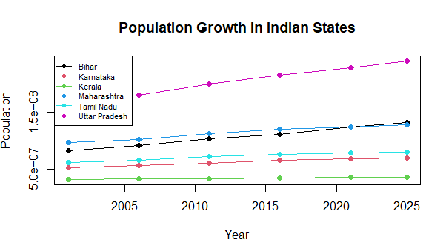

- Calculate the percentage change in population for different Indian states between selected years and compare the results using a bar graph.
We use percentage change to compare population growth among states of different sizes. It shows how much the population has increased or decreased relative to its starting population.
Formula:
Percentage Change=P2−P1P1×100
Formula explanation:
- P2​ = Final population.
- P1​ = Initial population.
- Multiply by 100 to express the result as a percentage.
Example: If the population increases from 50 million to 55 million:
55−5050×100=10%
Therefore, the population increased by 10%.
Code :
population <- population[order(population$State, population$Year), ]
states <- unique(population$State)
first <- population[!duplicated(population$State), ]
last <- population[!duplicated(population$State, fromLast = TRUE), ]
change <- ((last$Population - first$Population) /
first$Population) * 100
result <- data.frame(
State = states,
Percentage_Change = round(change, 2)
)
print(result)
barplot(result$Percentage_Change,
names.arg = result$State,
main = "Population Percentage Change (2001-2025)",
xlab = "States",
ylab = "Percentage Change (%)",
col = rainbow(6),
las = 2)
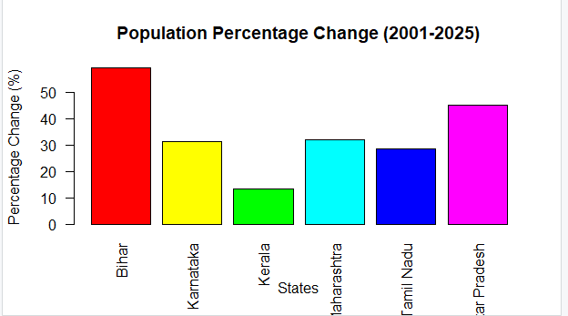
- Calculate the annual population growth rate of different Indian states and display the changes using a line graph.
We use the annual growth rate to understand how quickly a state's population grows per year on average. It is useful when comparing states over a period of several years.
Formula:
r=[(P2P1)1/n−1]× 100
Formula explanation:
r = Average annual population growth rate.
P1​ = Initial population.
P2= Final population.
n = Number of years between the two observations.
The formula calculates the average yearly percentage growth rate, accounting for growth over the entire period.
Example: If the population grows from 50 million to 55 million over 5 years:
r=[(5550)1/5−1]× 100
r≈1.92%
The average annual population growth rate is approximately 1.92%.
Code :
population <- population[order(population$State, population$Year), ]
population$Growth_Rate <- ave(
population$Population,
population$State,
FUN = function(x) c(NA, diff(x) / head(x, -1) * 100)
)
data <- population[!is.na(population$Growth_Rate), ]
print(data[, c("State", "Year", "Growth_Rate")])
states <- unique(data$State)
plot(data$Year, data$Growth_Rate,
col = match(data$State, states),
pch = 19,
xlab = "Year",
ylab = "Growth Rate (%)",
main = "Population Growth Rate by State")
legend("topright", legend = states,
col = seq_along(states), pch = 19,
cex = 0.7)
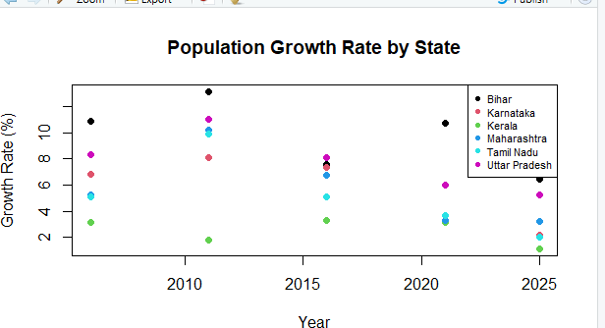
- Question: Compare the population of different Indian states in the latest available year and represent their population shares using a pie chart.
We use this analysis to understand how each state's population contributes to the combined population of the selected states. It helps us compare population distribution for one selected year.
Formula:
Population Share=State PopulationTotal Population×
Formula explanation:
- State Population = Population of one state in the selected year.
- Total Population = Combined population of all six states in that year.
First, select the latest available year, calculate each state's share, and identify the states with the highest and lowest populations. Then create a pie chart.
Example: If a state has 20 lakh people out of a combined 100 lakh, its share is 20%.
Code :
latest_year <- max(population$Year)
latest <- population[population$Year == latest_year, ]
latest$Share <- latest$Population /
sum(latest$Population) * 100
print(latest[, c("State", "Population", "Share")])
cat("Highest population state:",
latest$State[which.max(latest$Population)], "\n")
cat("Lowest population state:",
latest$State[which.min(latest$Population)], "\n")
pie(latest$Population,
labels = paste0(latest$State, " ",
round(latest$Share, 1), "%"),
main = paste("Population Distribution in", latest_year)
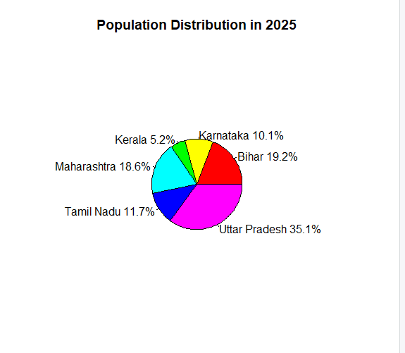
col = rainbow(nrowlatest)))

- Question: Identify the fastest-growing and slowest-growing Indian states using their population growth rates over the available period and present the results using a dot plot.
We use this analysis to rank states according to their total percentage population growth. It helps us identify the states with the highest and lowest growth rates over the same period.
Formula:
Growth Rate=P2−P1/P1×100
Formula explanation:
P1 = Population at the beginning of the period.
P2​ = Population at the end of the period.
Calculate the growth rate for each state using the same starting and ending years. Arrange the results from lowest to highest and display them using a dot plot.
The highest growth rate indicates the fastest-growing state.
The lowest growth rate indicates the slowest-growing state.
A negative rate indicates a population decrease.
Example: If State A grows by 15% and State B grows by 5%, State A has the higher population growth rate.
Code :
population <- population[order(population$State, population$Year), ]
first <- population[!duplicated(population$State), ]
last <- population[!duplicated(population$State, fromLast = TRUE), ]
growth <- ((last$Population - first$Population) /
first$Population) * 100
result <- data.frame(
State = first$State,
Growth_Rate = round(growth, 2)
)
result <- result[order(result$Growth_Rate), ]
print(result)
cat("Slowest-growing state:",
result$State[1], "\n")
cat("Fastest-growing state:",
result$State[nrow(result)], "\n")
dotchart(result$Growth_Rate,
labels = result$State,
main = "Population Growth Ranking",
xlab = "Growth Rate (%)",
pch = 19)
